

Fire Fighting Robot
Group Names:
Jana Hassan: 2025/00217
Janna Yasser: 2025/03567
Menna Tullah Khaled: 2025/06272
Eyad Emadeldeen: 2025/06546
Hazem Medhat: 2025/00726
Yassin Mohamed : 2025/02706

Contents
Fire Fighting Robot 1
K-Map: 2
Boolean Expression 3
Circuit Design: 4
The Truth Table 5
Truth Table of the water pump 6
Code of the Robot: 7
Its components 8
The Simulator(circuit design)…………………………………………………………………………………….9

Fire Fighting Robot
This digital logic design combines a flame Sensors to detect fire The
system is built using basic digital logic components. The block diagram shown below illustrates the working of a fire-fighting robot using an Arduino UNO as a central controller.

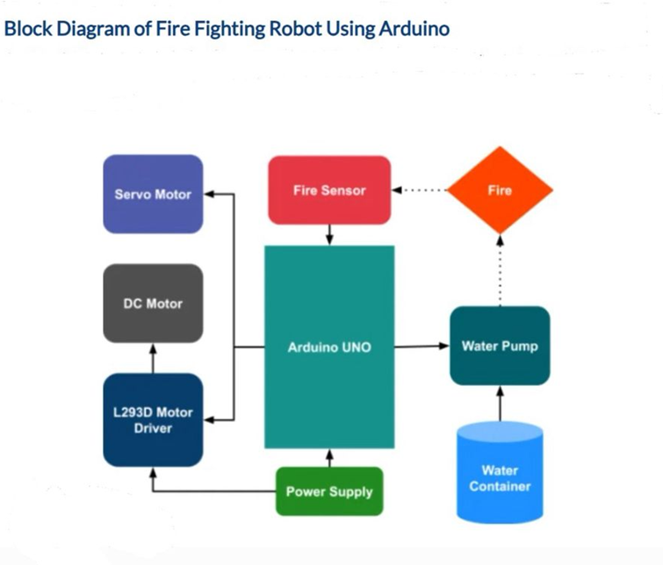

K-Map:

F( R, F, L)= ⅀m(2,3,4,5,6,7)
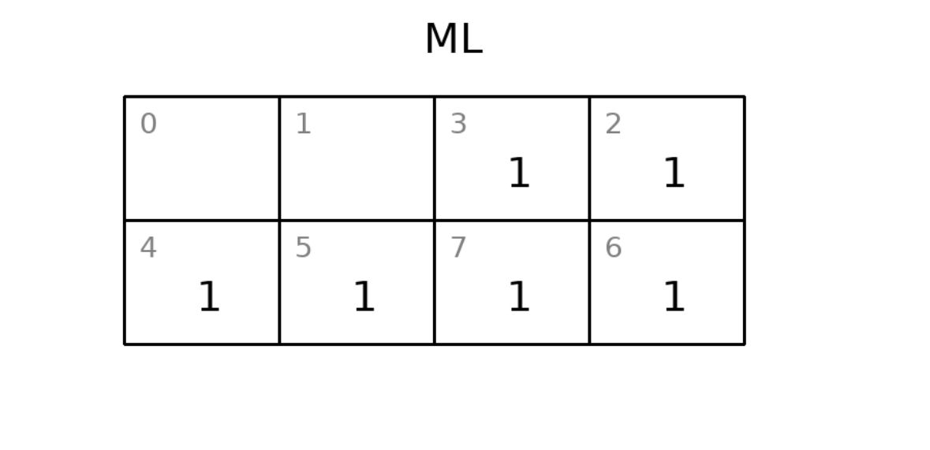

F( R, F, L)= ⅀m(1,2,3)
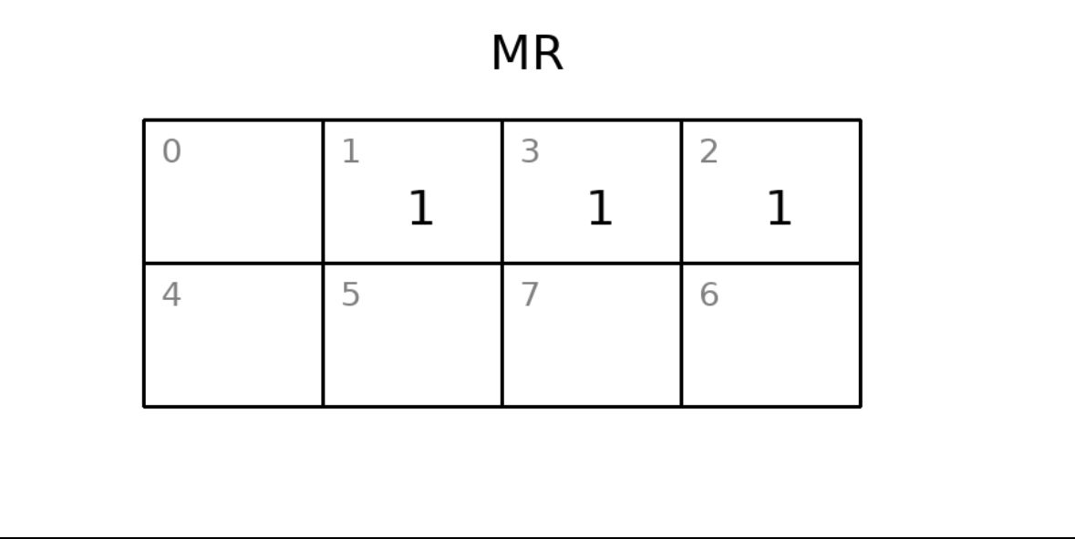

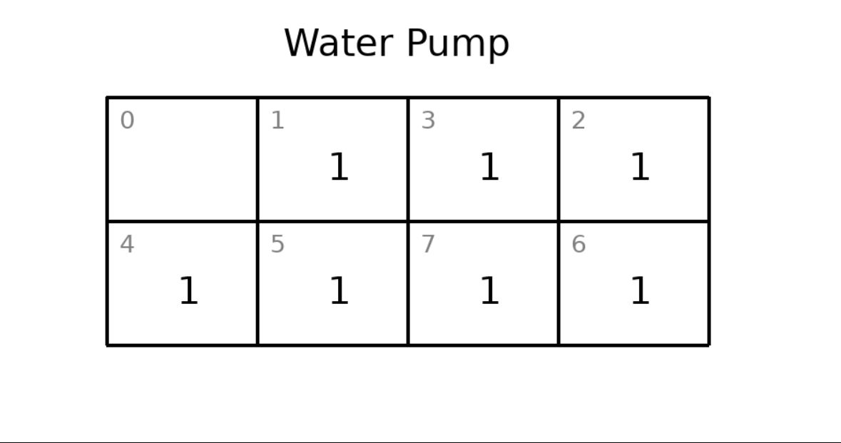
F( R, F, L)= ⅀m(1,2,3,4,5,6,7)

Boolean Expression
The system follows a priority-based logic where the right sensor dominates over front and left sensors, which is reflected in the Boolean expressions.

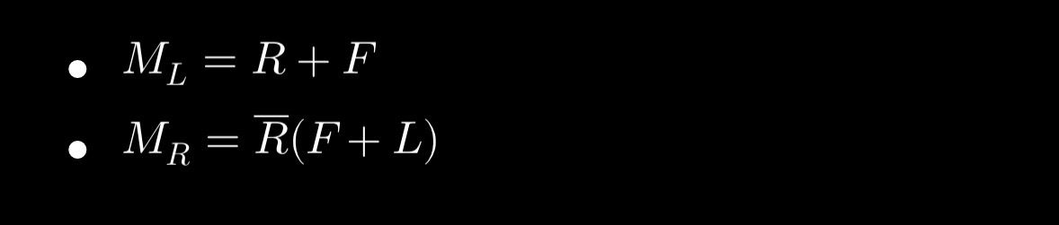

Circuit Design:

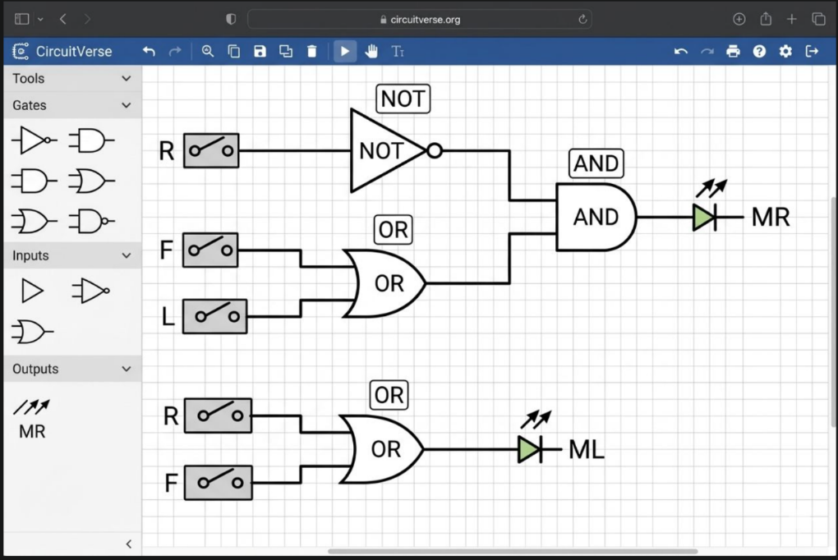
The circuit is designed using basic digital logic gates — including NOT, OR, and AND gates — to process signals from three inputs: R (Right sensor), F (Front sensor), and L (Left sensor). Based on the Boolean expressions ML = R + F and MR = R̄(F + L), the circuit determines the motor outputs to steer the robot toward the fire source. The logic prioritizes the right sensor, ensuring the robot turns or moves in the correct direction when fire is detected on any side.

The Truth Table


- R, F and L are the inputs ML and MR the outputs.
- As an input:
The system uses three input sensors (Right, Front, Left) to determine the robot’s movement using combinational logic.
- As an output:
ML and MR represent the control signals for the left and right motors, determining the robot’s movement.
The outputs (ML and MR) are simplified representations of motor control signals derived from the Arduino code.

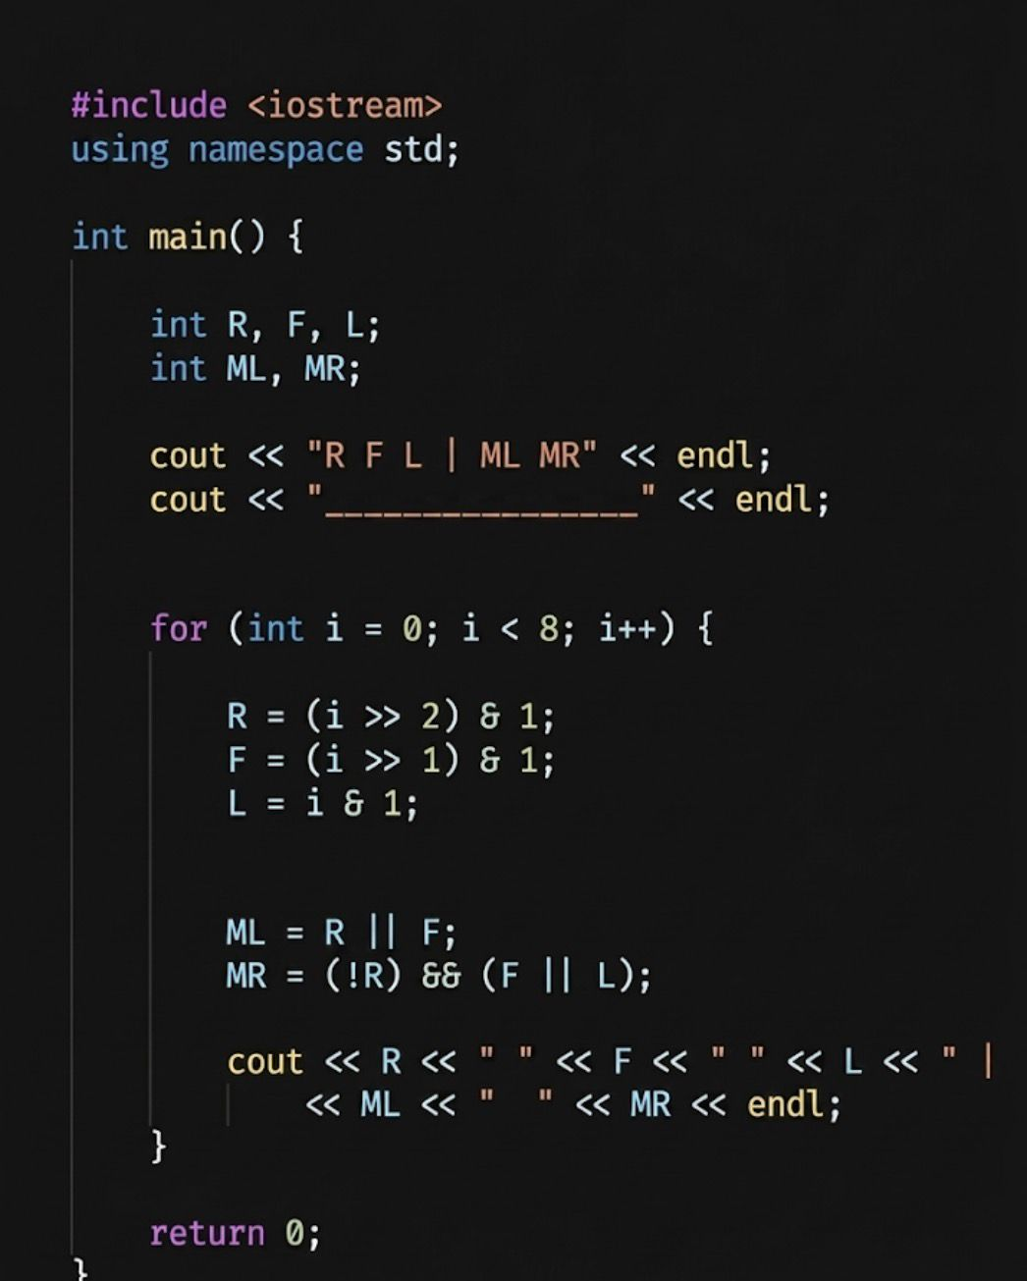
- And here is the following code of the truth table:

Its output:
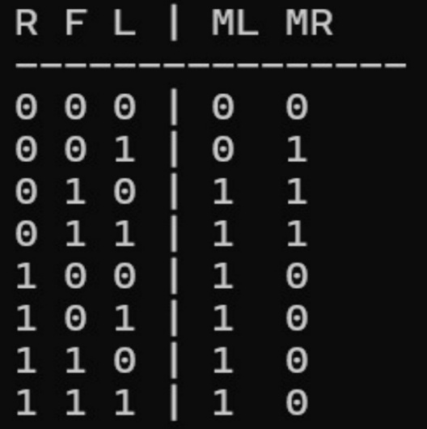

The following link allows testing the truth table implementation using an online C++ compiler:

https://www.programiz.com/online-compiler/4NTxX2yOIBQVf

Truth Table of the water pump:

This table now represents a 3-input OR logic gate (L+F+R). This means the pump will activate if any of the three sensors provides a signal (1), and it will only stop if all sensors are at (0).

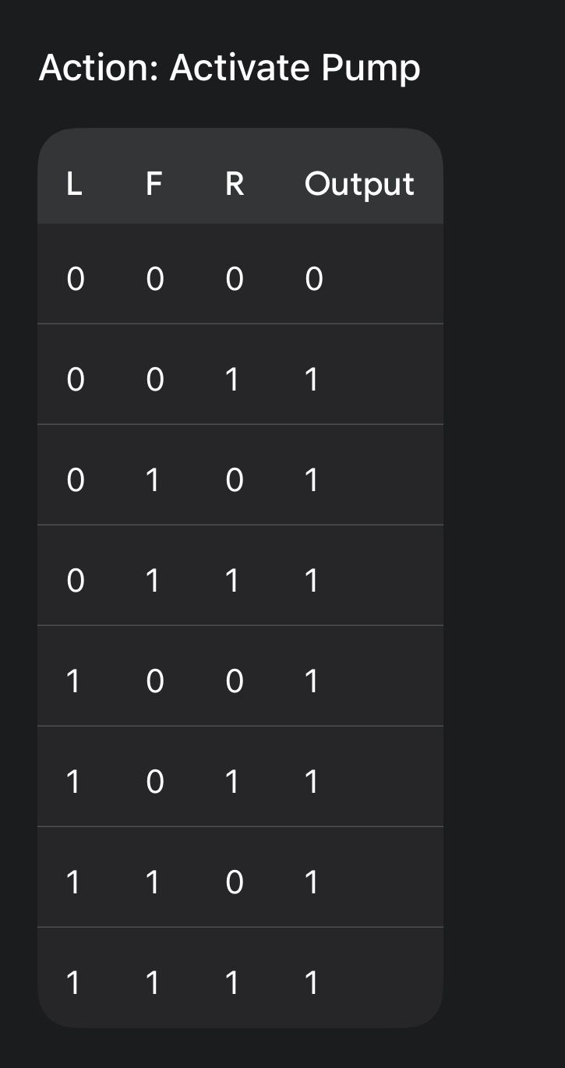

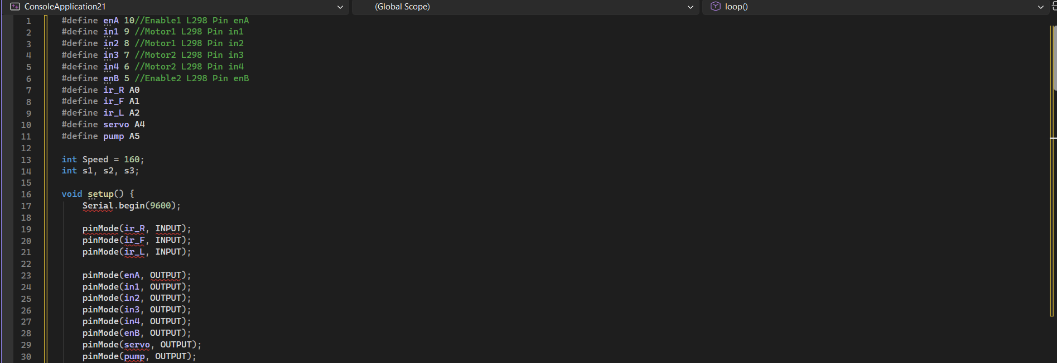
Code of the Robot:

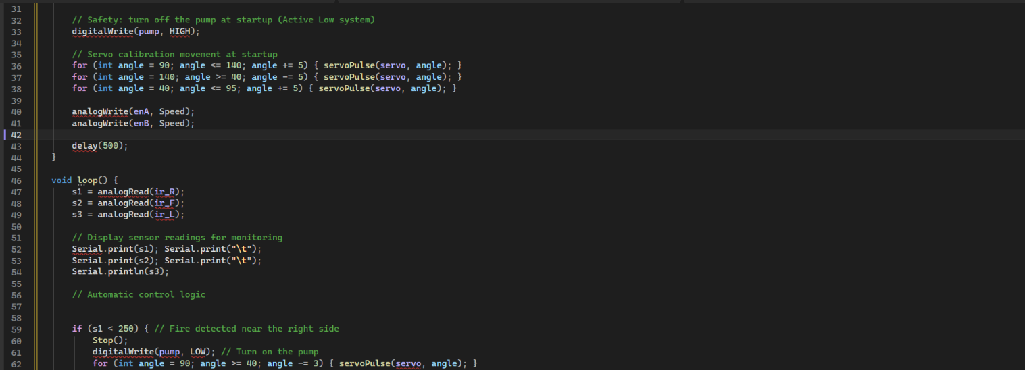

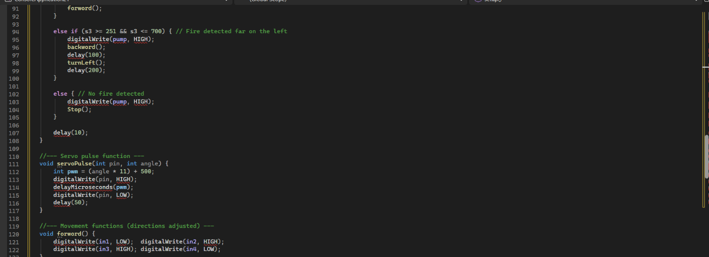
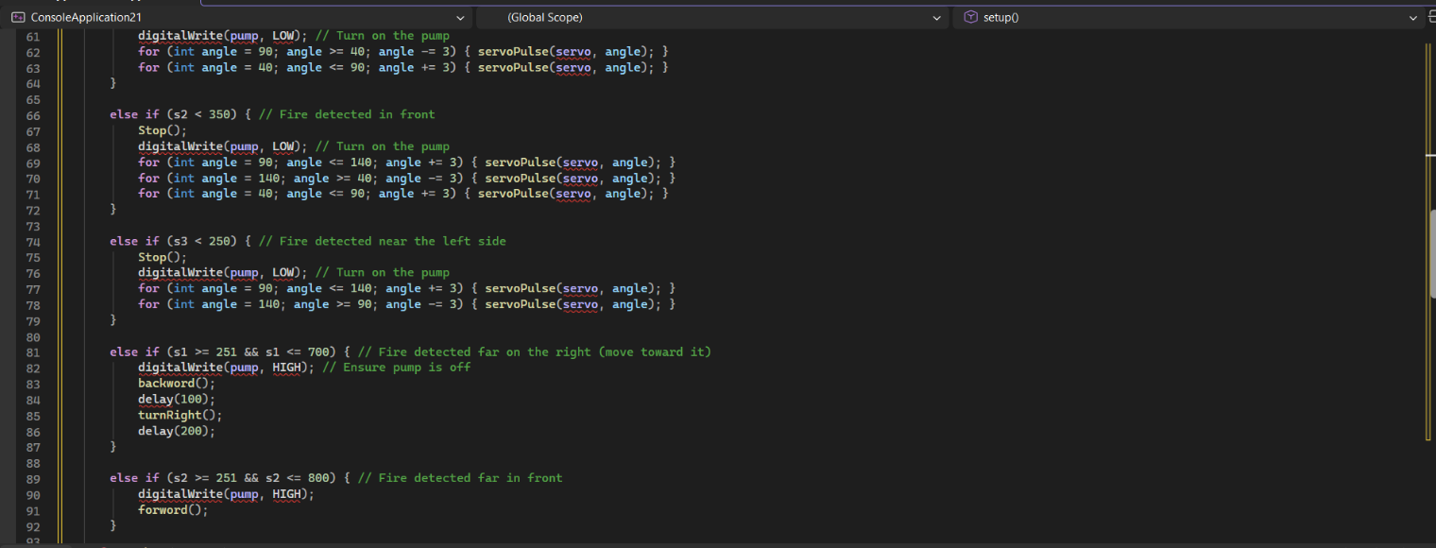
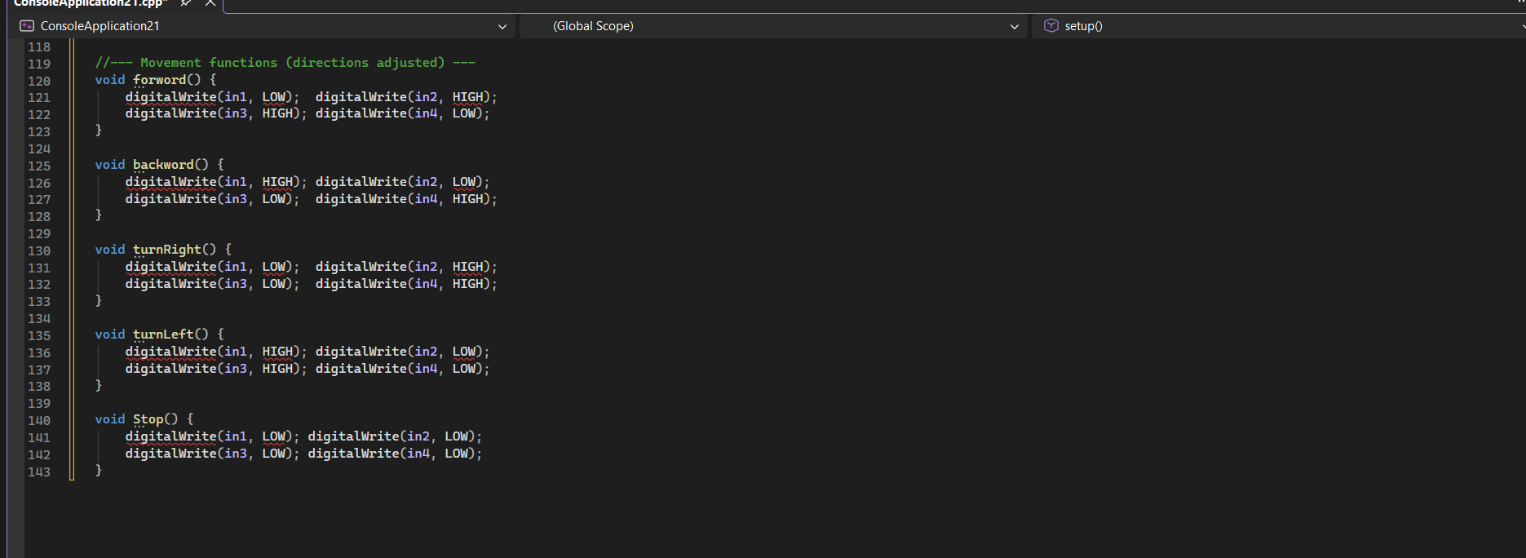

Its components:
Flame Sensor 4 Pin | IR Flame Sensor  Detects fire by sensing infrared light from flames. Commonly used in fire alarms and firefighting robots.
DC Geared  Motor with  wheel | DC Gear Motor  Converts electrical energy into rotational motion. The built-in gearbox reduces speed while boosting torque — ideal for driving wheels or moving platforms.
L298 Motor  Driver  Module | Motor Driver Module (L298N)  Acts as a bridge between a microcontroller and motors, enabling speed and direction control using low-power signals since microcontrollers can't directly power motors.
Breadboard | Breadboard  A solderless prototyping board for building and testing circuits. Components plug into internally connected rows and columns for easy, reusable wiring..
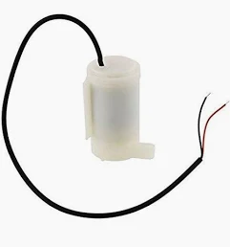  Submersible  Water Pump  5V | Submersible Water Pump  Pumps water when submerged. Used in irrigation systems, aquariums, or firefighting robots to spray water upon fire detection..
ON/OFF Black  Switch 2 Pins  KCD1-11  Dim:14*9mm | Rocker Switch  A simple physical switch that connects or disconnects power from a circuit. Typically serves as the master power switch for a project or device.

18650  Battery Cell  (USED) -  1800mAh | Li-ion Rechargeable Battery  A portable, rechargeable power source that supplies energy to all project components — motors, pump, and microcontroller — making the robot cordless and mobile.
Servo SG90  180° | Servo Motor  Rotates to a precise angle between 0–180°. In a firefighting robot, it aims the water pump nozzle toward the direction of the detected flame.
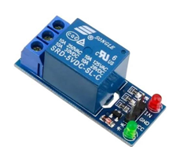  Relay one Chanel | Relay Module  An electrically controlled switch that lets a microcontroller turn high-power devices (like a water pump) on or off using a low-power signal, while keeping the control and power circuits safely isolated.
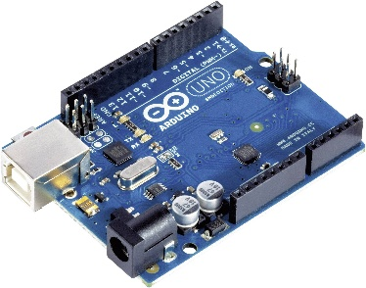  Arduino Uno | Arduino Microcontroller  The brain of the project. It reads inputs from sensors and buttons, then executes programmed instructions to control outputs like motors, LEDs, and pumps. Open-source and beginner-friendly.

The Simulator(circuit design):

The circuit diagram above illustrates the complete wiring and connections of the firefighting robot system. At the core of the design is the Arduino Uno microcontroller, which serves as the brain of the robot, processing inputs from the three flame sensors positioned to detect fire from multiple directions. Based on the sensor readings, the Arduino sends control signals to the L298 Motor Driver Module, which drives the four DC geared motors responsible for the robot's movement toward the flame. Simultaneously, the Arduino controls the servo motor to aim the water nozzle in the direction of the detected fire, and triggers the relay module to activate the submersible water pump, which delivers water through the PU tube to extinguish the flame. The entire system is powered by two 18650 lithium-ion battery cells connected through an ON/OFF switch, ensuring safe and controlled power delivery to all components. This design reflects a well-integrated embedded system where sensing, decision-making, motion, and actuation all work together seamlessly.